ASSIGNMENT 1

SOFTWARE DEVELOPMENT LIFE CYCLE FOR PROFILE WEBSITE

INTRODUCTION

SDLC

The Software Development Lifecycle is a systematic process for building software that ensures the quality and correctness of the software built. SDLC process aims to produce high-quality software which meets customer expectations. The software development should be complete in the pre-defined time frame and cost.
SDLC consists of a detailed plan which explains how to plan, build, and maintain specific software. Every phase of the SDLC lifecycle has its own process and deliverables that feed into the next phase.

SDLC Phases :
- Requirement Collection and Analysis
- Design
- Implemenation or Coding
- Testing
- Deployment
- Maintenance
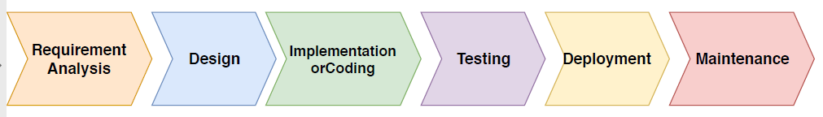

Phase 1: Requirement Collection and Analysis:
The requirement is the first stage in the SDLC process. It is conducted by the senior team members with inputs from all the stakeholders and domain experts in the industry. Planning for the quality assurance requirements and recognization of the risks involved is also done at this stage. This stage gives a clearer picture of the scope of the entire project and the anticipated issues, opportunities, and directives which triggered the project. Requirements Gathering stage need teams to get detailed and precise requirements. This helps companies to finalize the necessary timeline to finish the work of that system.
The requirements can be of five types:
- Business Requirements
- User Requirements
- Functional Requirements
- Quality-of-service Requirements
- Implementation Requirements
The website requirements are the list of necessary functions,capabilities or characteristics related to the website and the plans for creating it.Website requirements specifies what your website must have and what it must allow the users to do.Requirements do not tell you how to design or develop the site to have those features,functions and content.
Business Requirements define the objectives and what the stakeholder intends to solve with the product.User Requirements describe how user expectations and how they will interact with the product.Functional Requirements provide details of how a product should behave and specify what is needed for development.Quality-of-Service Requirements detail what characteristics a product must maintain in order to maintain its effectiveness and any constraints.Implementation Requirements are used to detail changes in process, team roles, migration from one system to another, etc.
- The business requirements for this assignment is to develop a profile website that is defined by the LMS.The main objective defined is to create our own profile website that is going to be the best way to introduce ourselves to the organization.
- The user requirements are the people who is going to visit my own website to know about myself.Henceforth the user expecations would be how easily they can interact with the website and the usability of the website.This requirement specifies the user experience and the interface taht is going to help the people to easily interact with the website.
- The functional requirements specifies how feasible the profile website has to be,how to behave and the the tools needed for the development.
- The profile website must include the home page which contains the basic information about myself,personal information,Academics,achievements,Gallery,contact information and other skills.The tools that is required for the development can be HTML,CSS,Jquery,Visual Studio,IIS,Git and Wireframe.
- The Quality-of-service requirements can be the constraints and the aesthetics of the profile website.The look and feel experience is considered by maintaining the same font style,theme and colour combination for the website.
- The Implementation requirements are the various methods and ways to achieve the goal.The methods to devlop the profile website can be implementing HTML to devlop the site and CSS to improve the styling of the website.The jquery includes the functionalities when implementing the slideshow.
This specification of requirements leads to the planning stage means creation of site map or the wireframe on how the final website has to be.The model that is going to be used for creating profile website is the Waterfall Model. The outcome of one phase acts as the input for the next phase sequentially. This means that any phase in the development process begins only if the previous phase is complete. The waterfall model is a sequential design process in which progress is seen as flowing steadily downwards (like a waterfall) through the phases of Conception, Initiation, Analysis, Design, Construction, Testing, Production/Implementation and Maintenance.This describes pictorail representation on the relations of various modules of the website.

Phase 2: Design:
After the planning stage,comes to the design part.This helps define overall system architecture.This design phase serves as input for the next phase of the model.The design includes high-level design and low-level design.
- The high-level design includes the brief description of each module,outline about the functionality of each module and relationship between each module.
- The low-level design includes the inputs and outputs of the modules,functional logic of the module.
The design includes the wireframe which describes the basic architecture on how the website has to look.A wireframe is a layout of a web page that demonstrates what interface elements will exist on key pages. It is a critical part of the interaction design process.The aim of a wireframe is to provide a visual understanding of a page early in a project to get stakeholder and project team approval before the creative phase gets under way. Wireframes can also be used to create the global and secondary navigation to ensure the terminology and structure used for the site meets user expectations.
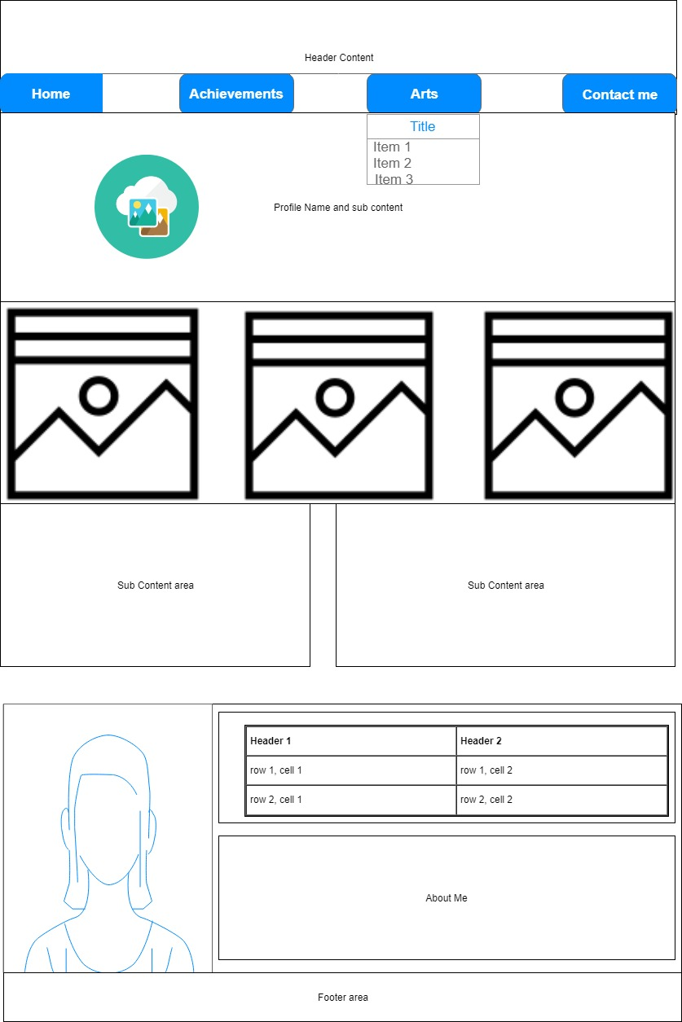
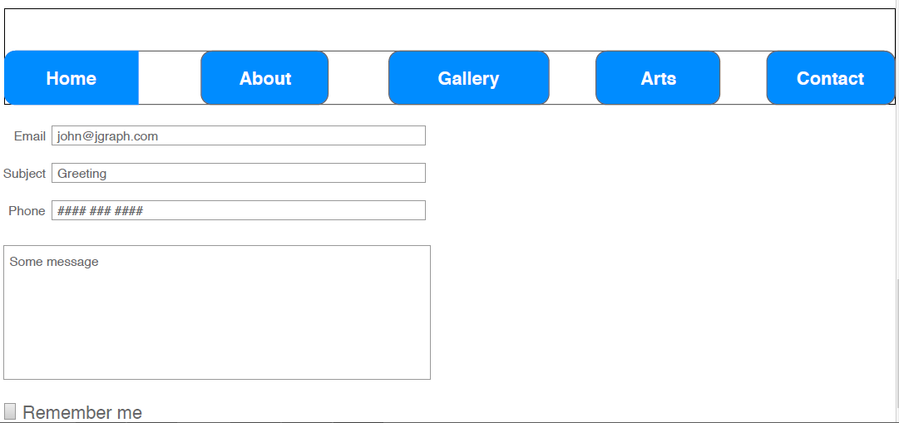The high-level design includes the pages like Home,About me,Academics,Gallery,Contact Information and Arts in a responsive way.
- The home page includes the Navigation bar,Background image,Information about Academics, Achievements,Technical stuff and hobbies.
- The aboutme page includes some additional information about myself.
- The Gallery page includes the slideshow of my pictures.
- The contact page includes the form page that asks for name,email id,phone number,message and a submit button.
- The arts page includes the images and information of the extra curricular activities like music,dance etc in a brief way.

The low-level design includes the logic of the modules.The Navigation is done when an item is clicked and jquery is implemented for the slideshow.

Phase 3: Implementation or Coding:
Once the system design phase is over, the next phase is coding. In this phase, developers start build the entire system by writing code using the chosen programming language. In the coding phase, tasks are divided into units or modules and assigned to the various developers. It is the longest phase of the Software Development Life Cycle process.
The implementation phase is the development phase of the profile website using various languages and style sheets to create the user interface.
The coding includes the use of front end languages like HTML5 and CSS.
HTML5 is used to design the various pages of the profile website.HTML stands for Hyper Text Markup Language. It is used to design web pages using markup language. HTML is the combination of Hypertext and Markup language. Hypertext defines the link between the web pages. Markup language is used to define the text document within tag which defines the structure of web pages.
CSS adds the styling of the profile pages like adding backgrounds,font style,font size,margins etc.CSS stands for Cascading Style Sheets, fondly referred to as CSS, is a simple design language intended to simplify the process of making web pages presentable.
CSS handles the look and feel part of a web page. Using CSS, you can control the color of the text, the style of fonts, the spacing between paragraphs, how columns are sized and laid out, what background images or colors are used, layout designs,variations in display for different devices and screen sizes as well as a variety of other effects.
jquery is being used to create the functionality of the slideshow of images in Gallery page.jQuery is a lightweight, "write less, do more", JavaScript library.The purpose of jQuery is to make it much easier to use JavaScript on your website.jQuery takes a lot of common tasks that require many lines of JavaScript code to accomplish, and wraps them into methods that you can call with a single line of code.

Phase 4: Testing:
The testing can be done using various browsers like Google Chrome,Mozilla firefox, Internet explorers to check whether the website is working as per the specifications.Also the code can be audited by using Google Light house which checks the performance,accessbility,quality and correctness of the app.

Phase 5: Deployment:
The testing can be locally on the host machine.Once the software testing phase is over and no bugs or errors left in the system then the final deployment process starts. Internet Information Services (IIS) is a flexible, general-purpose web server from Microsoft that runs on Windows systems to serve requested HTML pages or files.
An IIS web server accepts requets fromremote client computers and returns the appropriate response.This basic functionality allows web servers to share and deliver information across local area networks such as corporate networks and wide area networks,such as the internet.
A web server can deliver information to users in several forms such as static web pages coded in HTML;through file exchanges as downloads and uploads,text documents and image files etc.

Phase 6: Maintainance:
Once the system is deployed, and customers start using the developed system.Enhancemements can be done to the according to the updated versions by adding some features.

